An Update from the State House
This week is the last week before legislative vacation break which takes place April 15-19. Following the break, we can expect to see committees voting on bills and sending them to the House and Senate floor for consideration. The final Revenue Estimating Conference has been scheduled for May 10th at 9:00 a.m. This day-long meeting will result in a determination of the final revenues available for the FY2020 budget, allowing lawmakers and staff to definitively draft a budget.

Small Business Loan Program Hearing
Part of the Senate Economic package includes a small business loan program that provides investors with a state tax credit. On Tuesday, April 9th at the Rise, approximate 4:30 p.m. in Room 211, the Committee will hear S.55 An Act Relating to State Affairs and Government (Conley, Cano, DiPalma, Felag, and Pearson) which proposed to establish a small business development fund designed to encourage the formation of private capital investment by federally licensed investment companies in underserved small businesses, leveraged by delayed, at-risk stream of tax credits applicable against insurance premium and retaliatory taxes that can be recaptured for noncompliance with program investment requirements. Monetary penalties would exist if job creation and retention projections would be missed, and the state shares in profits above a certain level of fund returns. Investments would be designated for targeted growth industries for the state, and would be required to be diversified – no one small business would receive more than four ($4,000,000) million or twenty percent (20%) of a fund's investment authority. The investment funds would report annually, and the program would terminate after six (6) years. http://webserver.rilin.state.ri.us/BillText/BillText19/SenateText19/S0055.pdf

Energy Is the Topic for Senate Environment & Agriculture
On Wednesday, April 10th, the Senate Environment & Agriculture Committee will host a presentation from the Independent System Operator of New England (ISO New England). The meeting will take place in the Senate Lounge at approximately 4:30 p.m. ISO New England is the independent, not-for-profit organization authorized by the Federal Energy Regulatory Commission to oversee the day-to-day operation of New England’s electric power generation and transmission system, administer the region's competitive wholesale electricity markets, and manage comprehensive regional power system planning. This is the organization that has been increasingly warning the state of the need for additional power generation as existing facilities are closed in the New England region. ISO does not advocate for any particular source of generation, but is responsible for ensuring energy is reliable.
S.659, (DiPalma, Goldin, Murray, Euer, Sosnowski) a Senate Resolution Requesting an Assessment of the Benefits to Rhode Island of Enactment of a Green New Deal will also be heard in the Committee Wednesday. It calls for a “bold alternative to business as usual” in order to combat climate change. The resolution requires the Rhode Island Green New Deal Research Council report their findings and recommendations regarding the potential benefits of green new deal initiatives to the Senate by May 15, 2019 for consideration. Rhode Island can be proud to say that it is 49th out of 50 in state rankings of the creation of Greenhouse Gas emissions in the United States. Vermont has the lowest emission rate.

State Job Growth Comparison
Some troubling statistics were recently released by the U.S. Bureau of Labor Statistics. The following table shows the change in jobs for the 50 states and the District of Columbia. According to Ted C. Jones, P.H.D, this analysis is based on seasonally adjusted data from the Bureau covering February, 2018 – February, 2019. Nevada leads the way with a 3.53% job growth over the past year, while Rhode Island comes in last at a -.32%
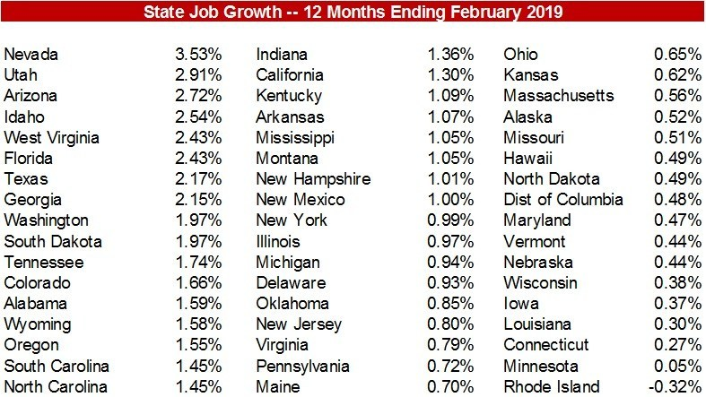

The following bills were filed last week:
House Bill No. 5945 Edwards, Canario, Shanley, Barros, AN ACT RELATING TO HEALTH AND SAFETY -- BIOMETRIC INFORMATION PRIVACY PROTECTION ACT (Prohibits collection of biometric identifiers without consent.)

House Bill No. 5949 Tobon, Barros, Edwards, Johnston, Blazejewski, AN ACT RELATING TO CORPORATIONS, ASSOCIATIONS, AND PARTNERSHIPS -- RHODE ISLAND BUSINESS CORPORATION ACT (Imposes a fee of one hundred sixty dollars ($160) for all domestic and foreign corporations for a certificate of authority to transact business in this state.)

House Bill No. 5957 Ranglin-Vassell, Donovan, Walsh, Barros, Diaz, AN ACT RELATING TO LABOR AND LABOR RELATIONS - WAGES (Increases min. Wage From $9 to $15 per hour by 1/1/24 and tipped min. Wage From $3.89 to $15 per hour by 1/1/28/Further increases depend on increases in CPI/Non-payment damage awards increased from 2 to 3 times unpaid amount/SOL increased from 3 to 6 yrs.)

Senate Bill No. 753 DiPalma, Lombardo, Conley, Gallo, Valverde, AN ACT RELATING TO FINANCIAL INSTITUTIONS -- LICENSED ACTIVITIES--CURRENCY TRANSMISSIONS (Adds virtual currency to the existing electronic money transmission and sale of check licenses and adds additional regulatory provisions to simplify and clarify licensing related thereto.)

Senate Bill No. 765 Goldin, Miller, Lawson, Satchell, Valverde, AN ACT RELATING TO LABOR AND LABOR RELATIONS -- TEMPORARY DISABILITY INSURANCE (Increases tax wage base for contributions to TDI /TCI, expands eligibility, increases benefit rates, adds sibling and grandchild in coverage benefits, increases temp caregiver weeks, and institutes fines for not reinstating an employee who uses program.)

Senate Bill No. 768 Picard, AN ACT RELATING TO STATE AFFAIRS AND GOVERNMENT -- MANUFACTURING AND ECONOMIC DEVELOPMENT--TAX INCENTIVES (Establishes the "refundable investment tax credit act" to provide for a refundable investment tax credit for certain investments in the construction of facilities, acquisition of tangible property, and the training of employees in the state.)

Senate Bill No. 776 Archambault, AN ACT RELATING TO MOTOR AND OTHER VEHICLES -- SIZE, WEIGHT AND LOAD LIMITS--SMITHFIELD AND LINCOLN (Prohibits commercial motor trucks, with a gross weight rating of twenty-six thousand one pounds (26,001 lbs.) or more, from traveling on Limerock Road, in Smithfield and Lincoln.)

